Lab 5: MySQL & PHP
Prepared: TrangNTT
Lab 6-1. MySQL & PHP 1
6.1. Configure MySQL Server Instance 2
6.2. Use MySQL Command Line Client to investigate the mysql database 7
6.3. Run the example in the lecture slides 10
6.4. Open and use phpMyAdmin to create a database and tables 13
6.5. Category Administration page 14
6.6. Business Registration page 15
6.7. Business Listing page 15

Configure MySQL Server Instance
Đã cài:
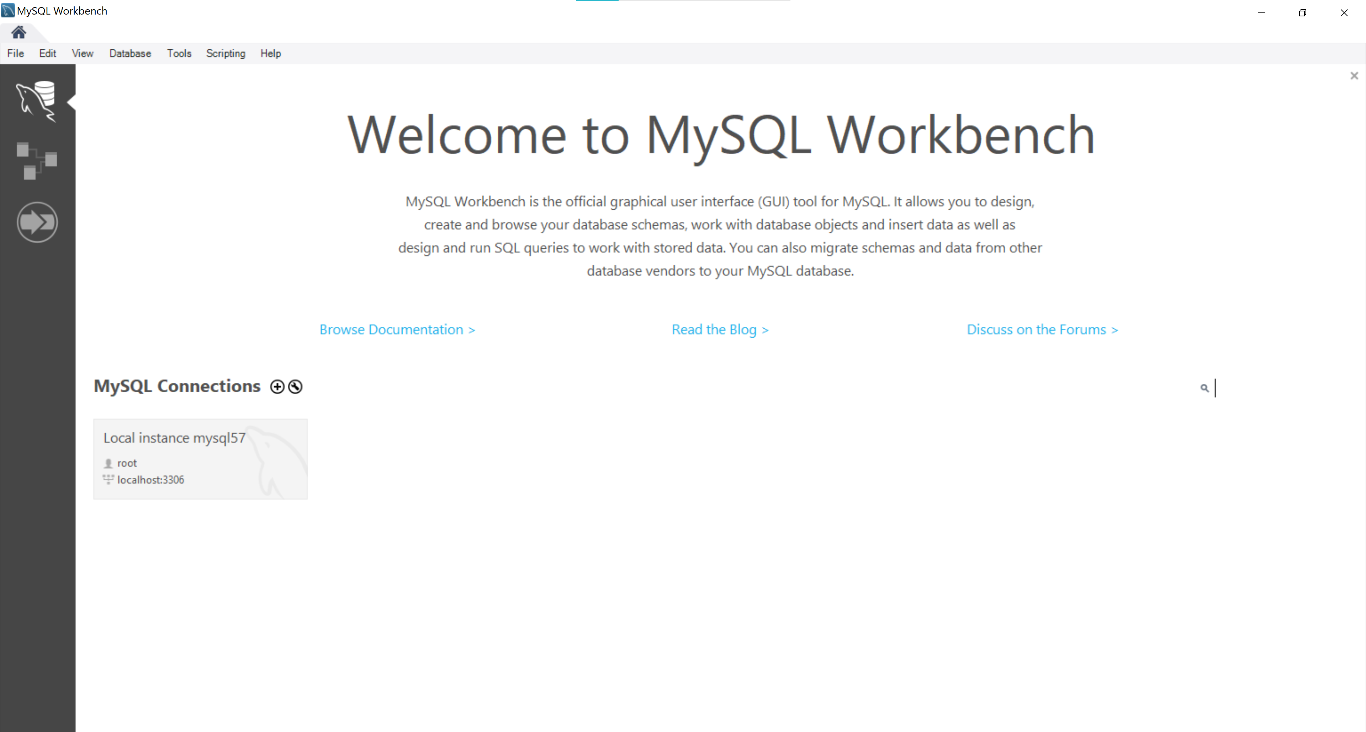

Use MySQL Command Line Client to investigate the mysql database

Change password for root username (if necessary)
- Select Start → All Programs → Zend Server Comminity Edition → MySQL Server 5.1 → MySQL Command Line Client. Enter password and press Enter.
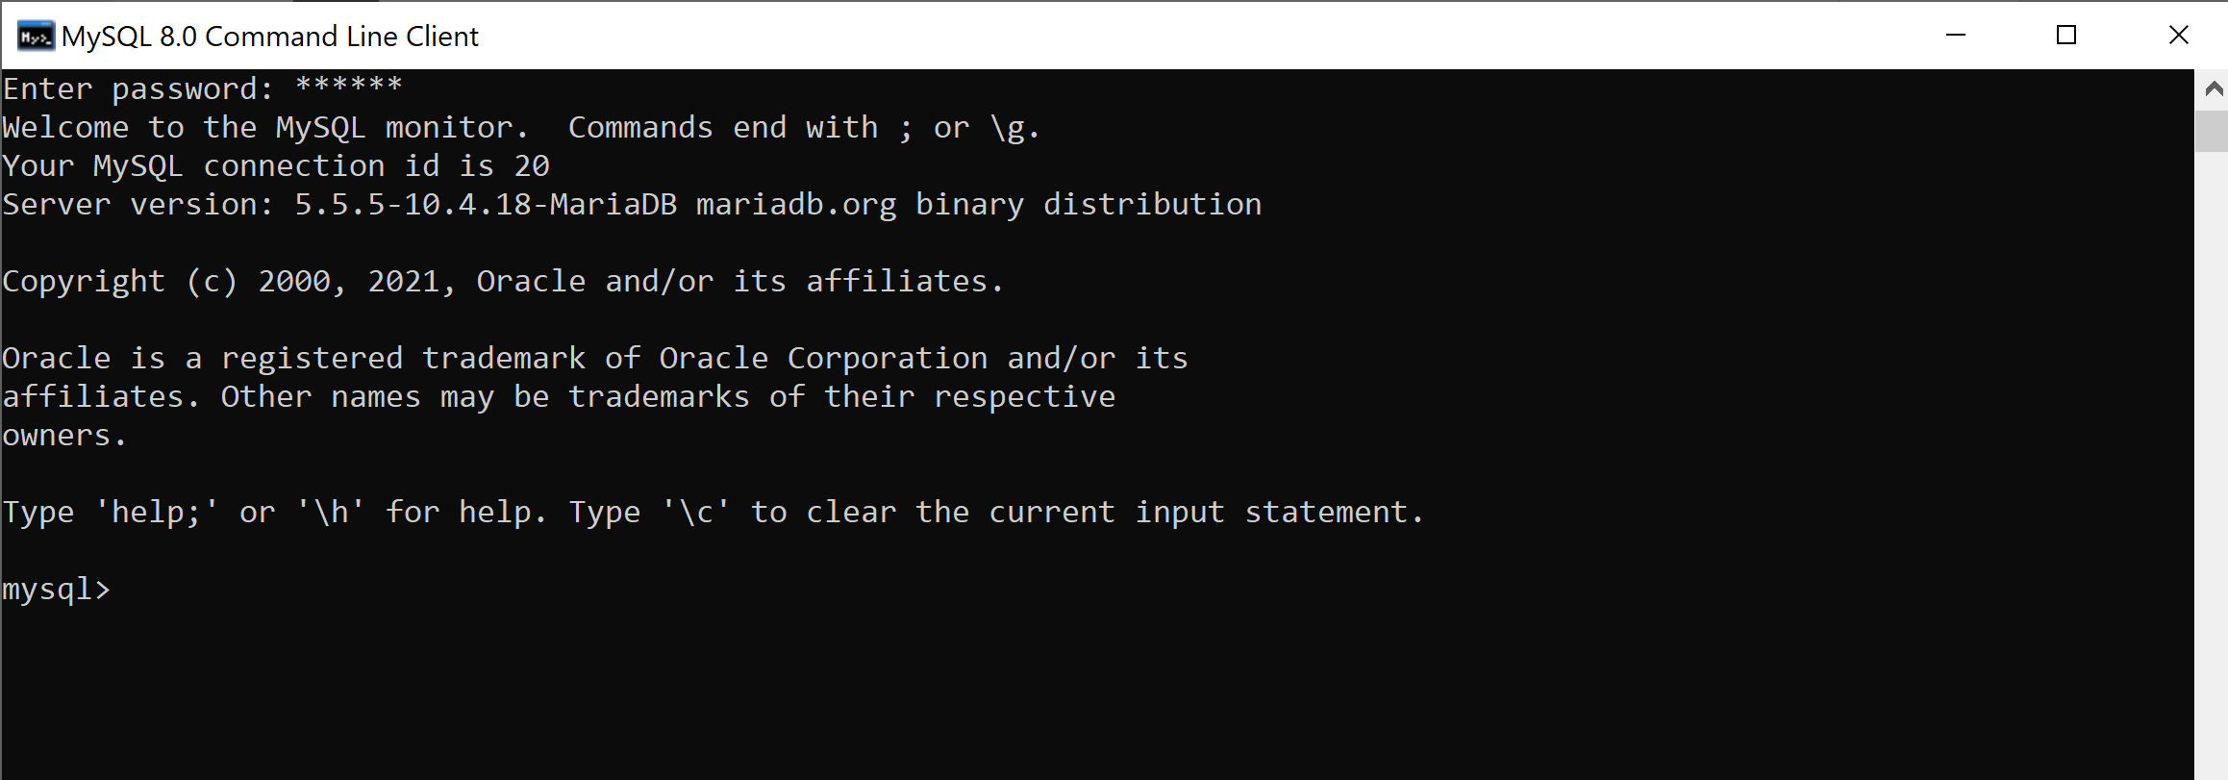
- Type: SET PASSWORD = PASSWORD('new_pass'); to change password for root.
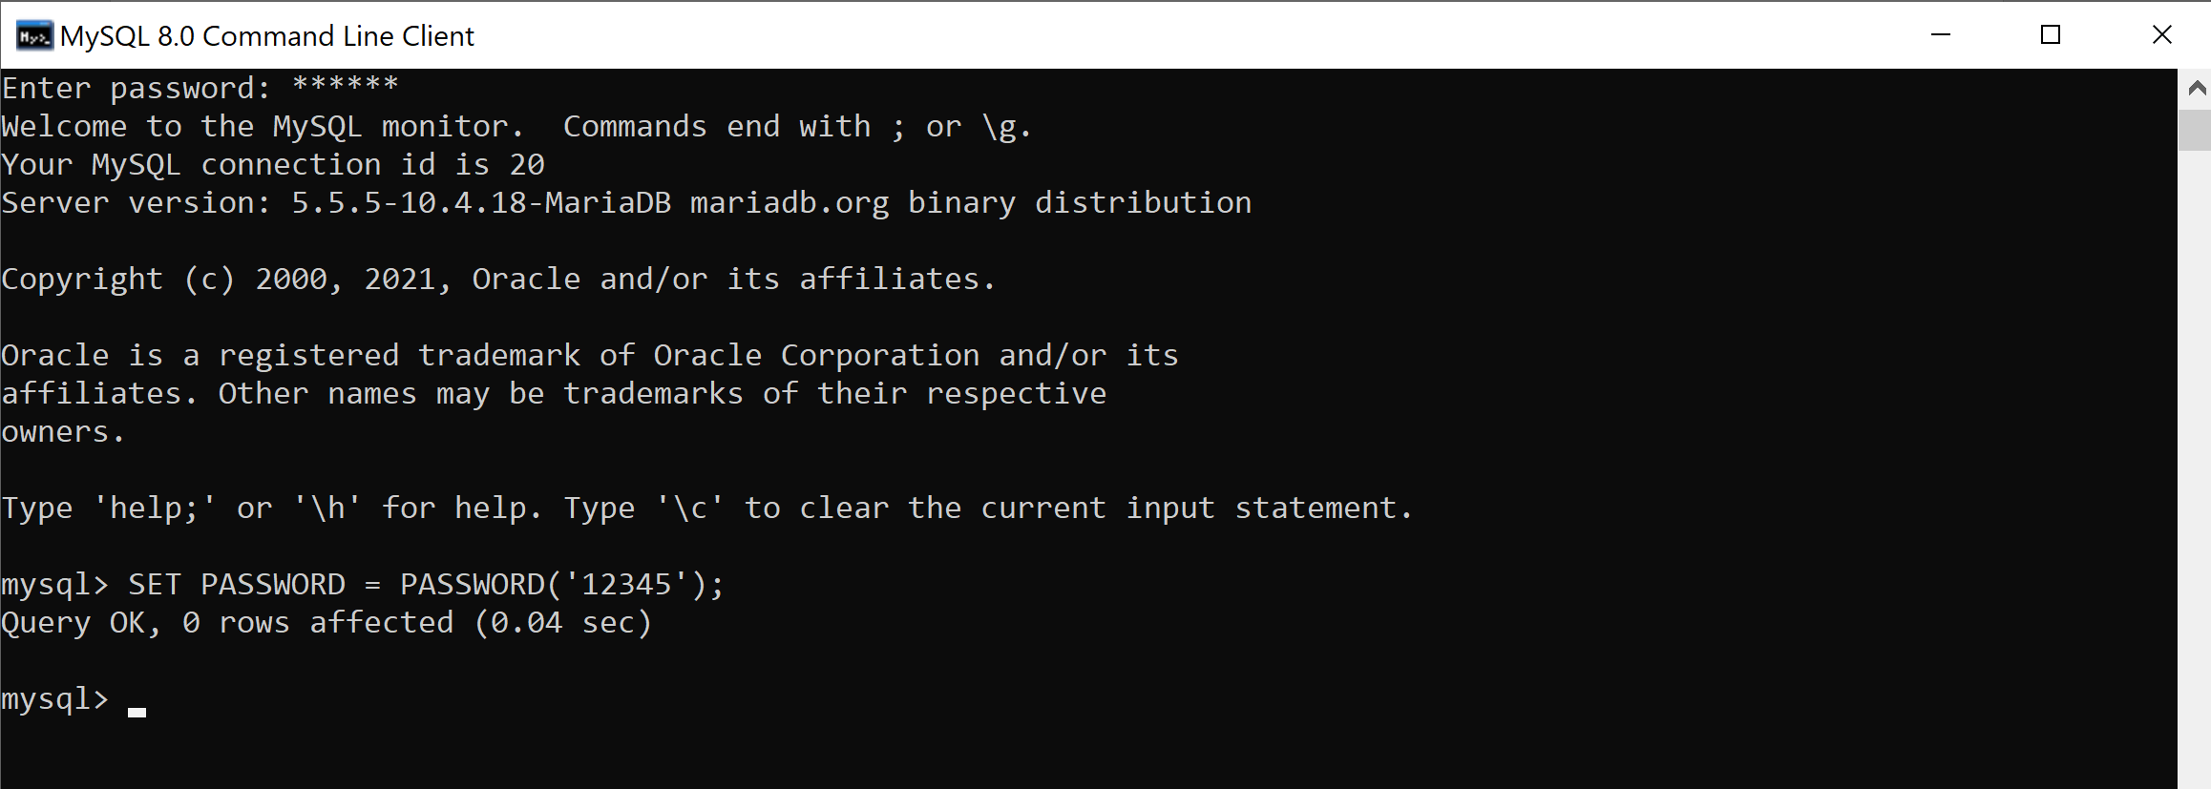

Investigate mysql database
- Show and use mysql database
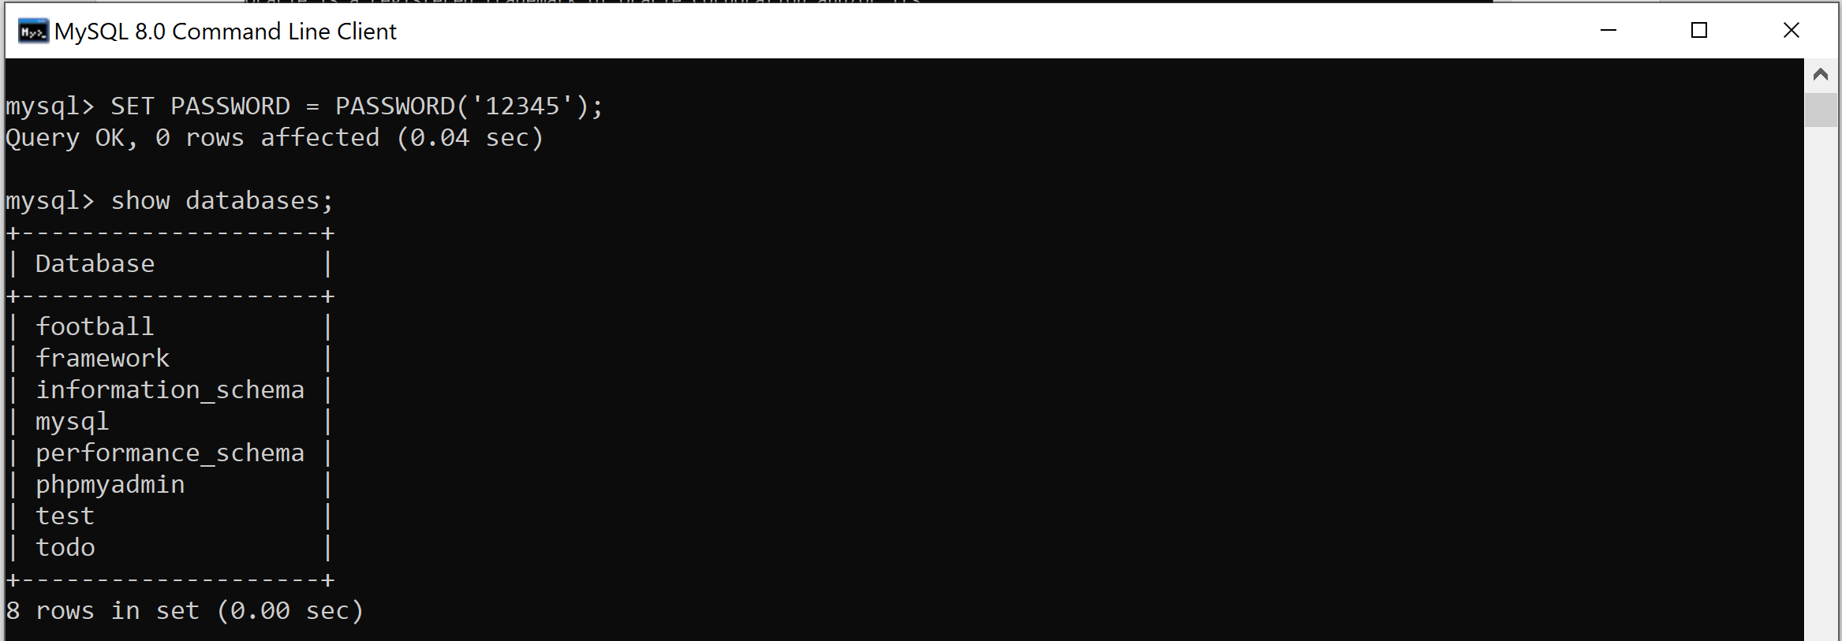
- Display all tables in the mysql database
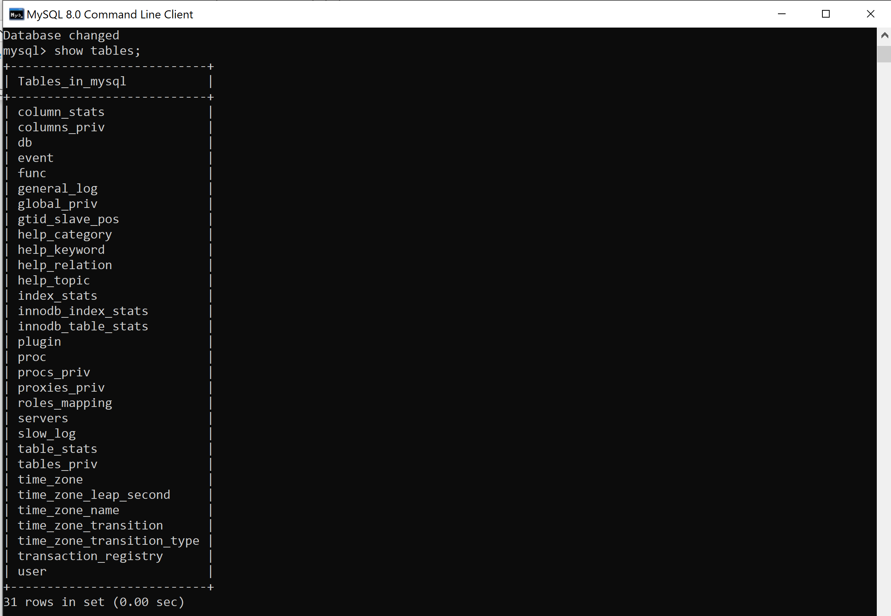
- View column details for user table
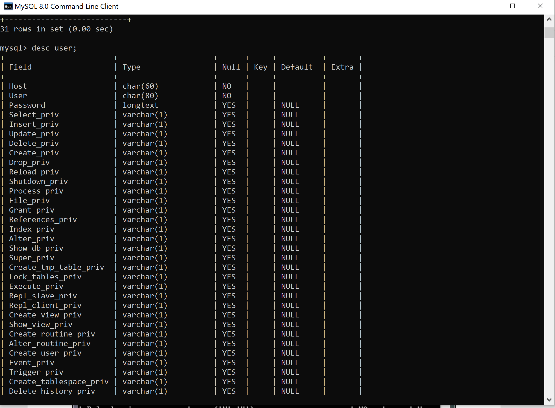
- Create database named sale to run examples from the lecture.
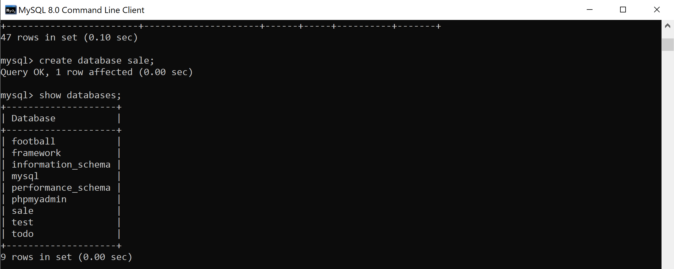

Run the example in the lecture slides

Create table Products using PHP scripts

The result after creating table successfully:
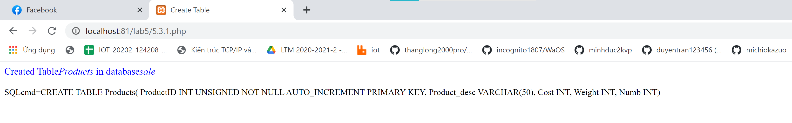

Insert data to Products
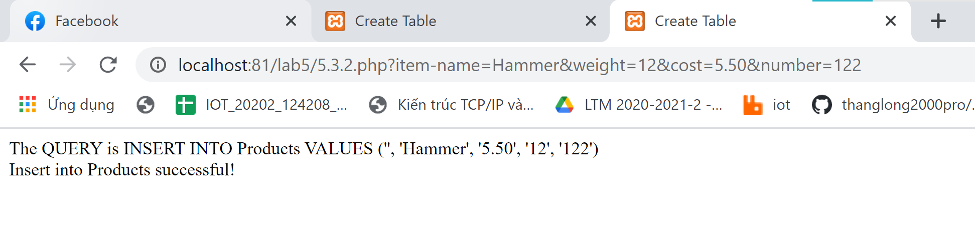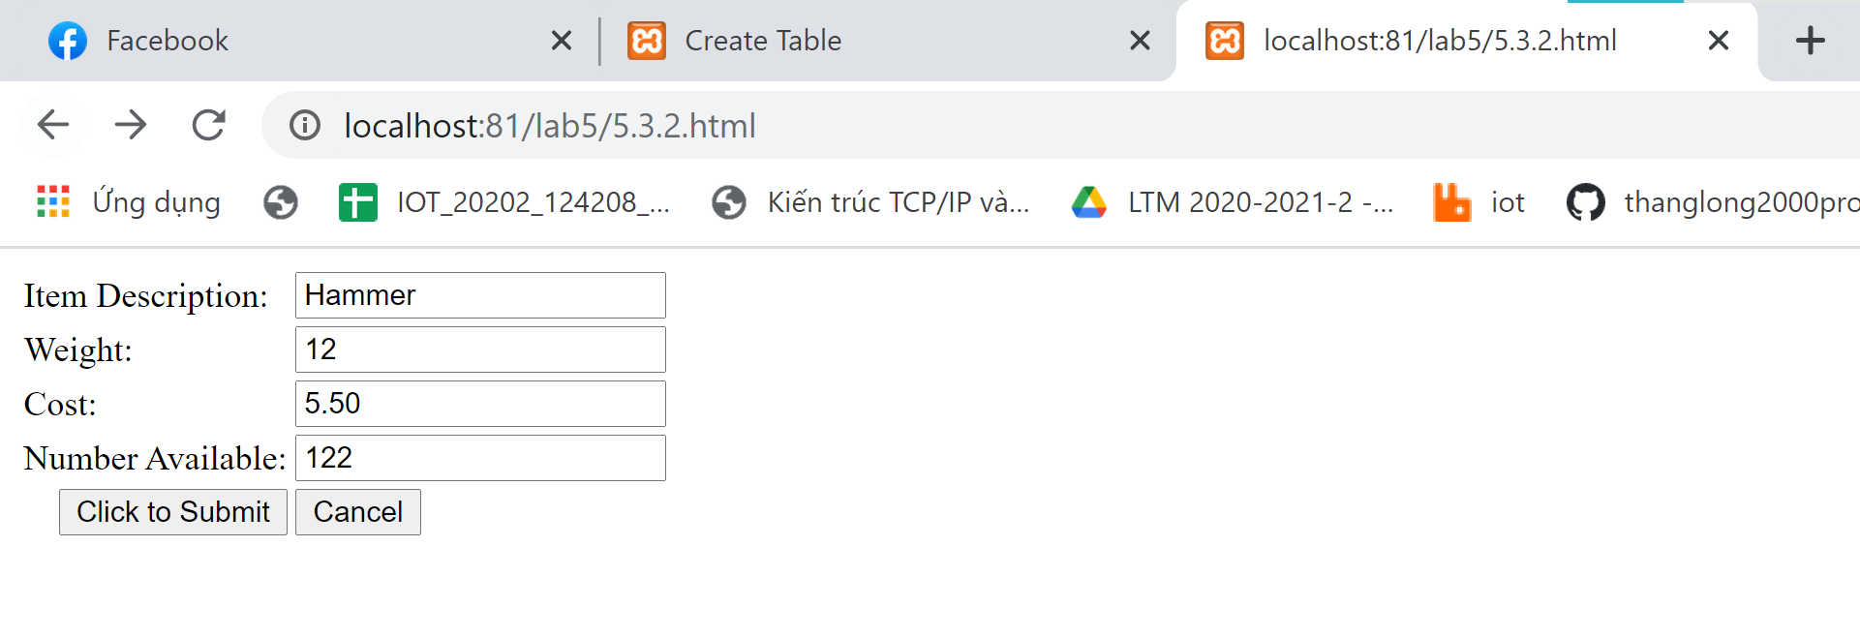

Display list of products
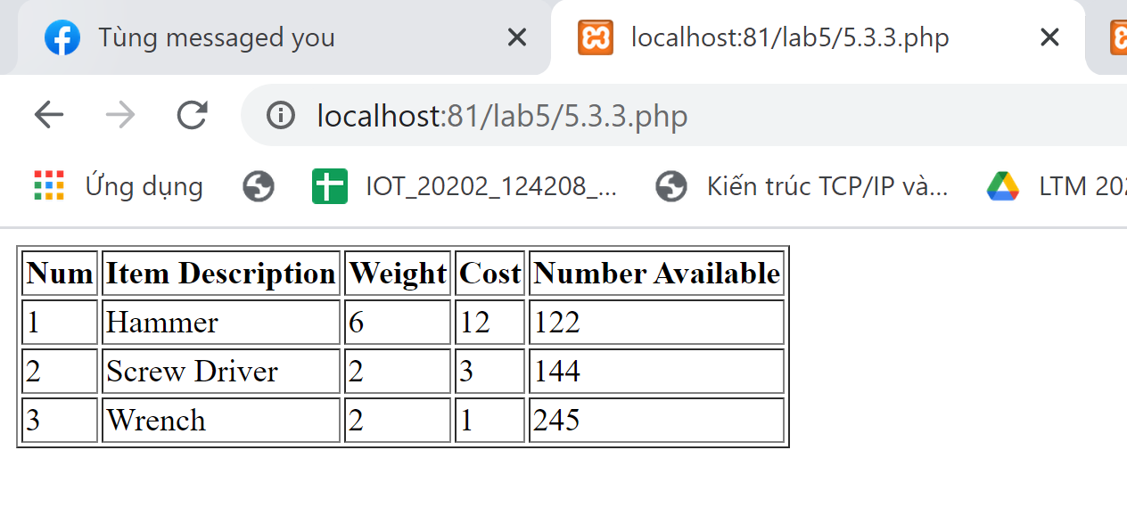

Search products
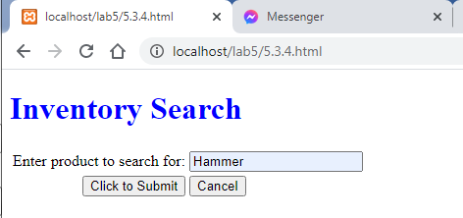
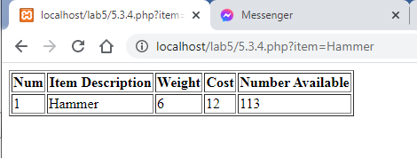

Update product
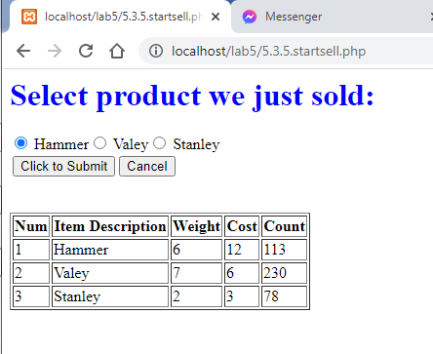
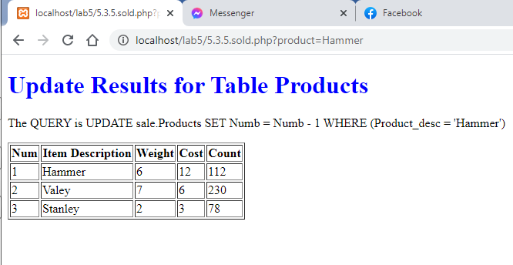

Open and use phpMyAdmin to create a database and tables

Open Zend Server Comminity Edition
Nhóm mình sử dụng Xampp thay thế

Open phpMyAdmin
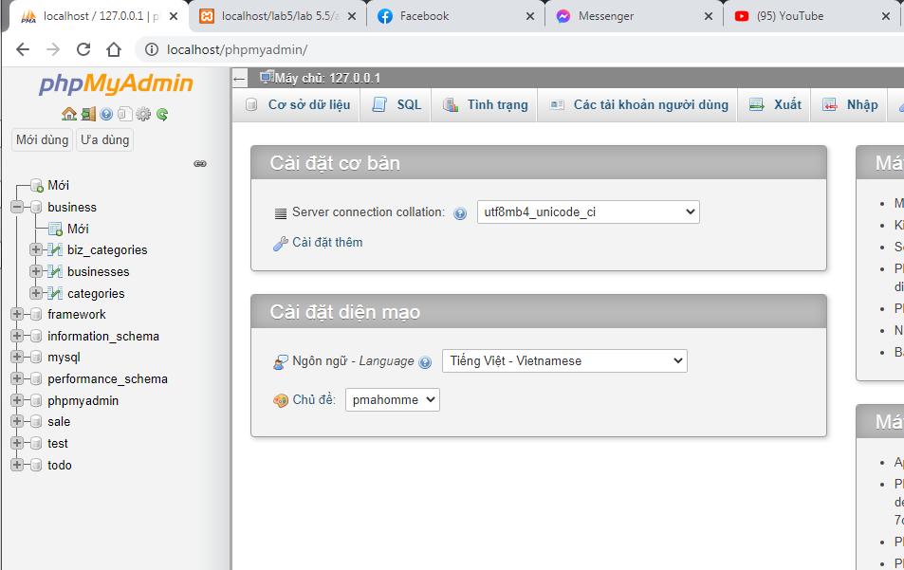

Create tables and relationships for business listing service
Create a database named business. 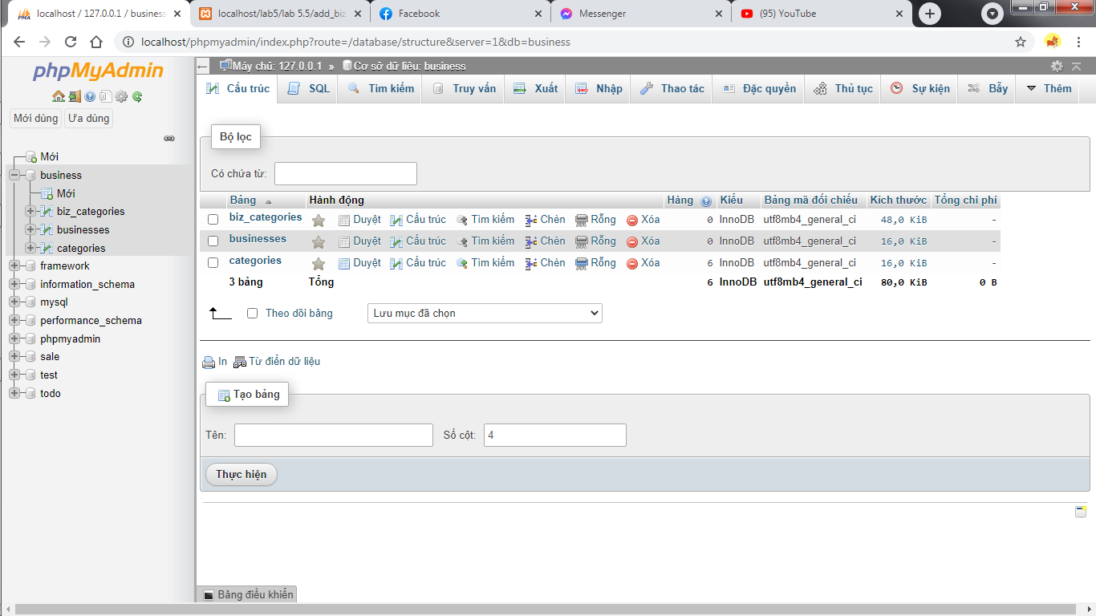

Category Administration page
Design the following page for Category Adminstration to add a category:
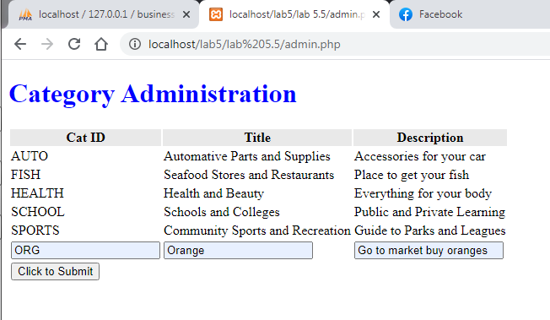
Sau khi submit: 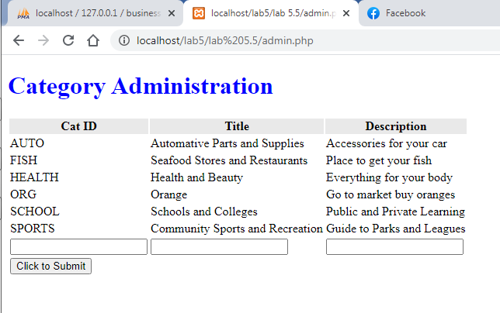

Business Registration page
Design the following page for Business Registration to add a business. Users can choose multiple categories for the business in the list in the left of the page.
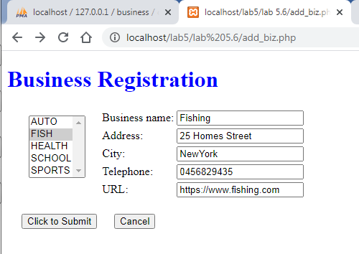
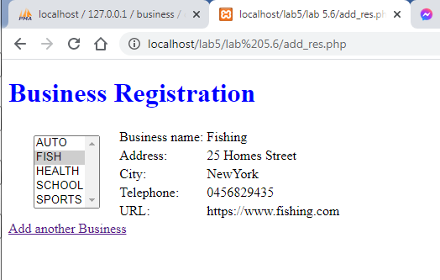

Business Listing page
Design the following page for Business Listing to display a list of businesses for a specific category. Users can click to the list of categories in the left view the list of corresponding businesses.
Main:
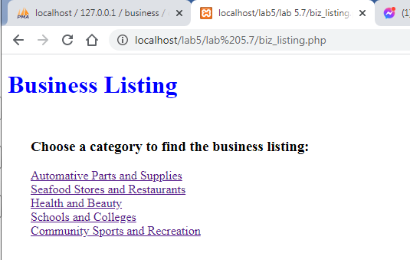
Category FISH:
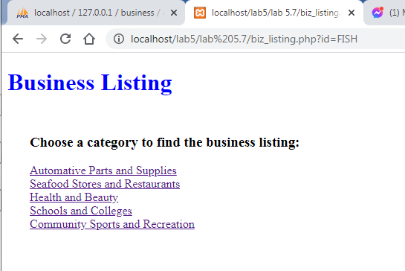
Category SCHOOL:

